abstract template for esb Conference: place your title here (“title” style). Maximum 2 lines

The author list goes here (“Authors” style)

Firstname Lastname (1), Firstname Lastname (2), Firstname Lastname (3)

Enter the affiliation information here (“Affiliation” style)
1. Affiliation, Country; 2. Affiliation, Country; 3. Affiliation, Country

Headings use “Heading” style
Abstracts must comply with the format described below. The required text styles illustrated in this Microsoft WORD document must be used as a template for production of abstracts, by replacing the relevant text with your own. The easiest way to use this abstract form is by cutting and pasting unformatted text into each section to maintain the document’s present format. Symbols can be included where appropriate using the Insert → Symbol functionality in Word.
The abstract should include the following sections: Introduction, Methods, Results, Discussion, and References. The text of the abstract body is Times New Roman, 10 point, single-spaced (“Normal” style). Include an empty line before each new section. Page layout is A4 portrait, 2.0 cm margins. Text boxes for title, authors and affiliations must not be moved.
The abstract should be compiled without changing the styles. Style modifications may lead to rejection without review.
Abstracts must not exceed one page (a word count of approximately 500 words).

Uploading Abstracts
The abstracts should be uploaded as PDF document through the conference website.
The maximum size of the PDF file is 1 Mb.
To reduce the size of your final abstract, it is possible to compress all images in the document by right-clicking on an image, choosing Format Picture, Compress and reducing all images in the document to printing resolution.

Figure and Tables
Please number figures and tables consecutively in the document. Figures should be embedded directly in the document, and be centered within the column.
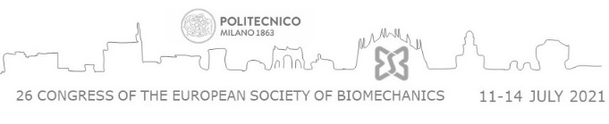

Figure 1: This figure can be removed and replaced by your figure. Captions should be included below each figure, using the “Captions” style. Multiple figures are allowed; please make sure that they are readable by using proper font size and line width.

Column 1 | Column 2 | Column 3
Data 1 | Data 3 | Data 5
Data 2 | Data 4 | Data 6
Table 1: Table captions are entered below the tables, using the “Captions” style.

Equations
Equations may be included in the abstract, using either the “Equation” style or by using the Word equation editor. The text fonts in the equation should be Times New Roman and Symbol, 10 point. Equations should be indented one tab stop from the left. Equations may be sequentially numbered.

E = mc² (1)

References
- Enter your references in this block using the “References” style. References should be listed in order of appearance and formatted as shown below. In the text, use numbering in brackets to indicate the references, e.g. [1].
- Somebody et al, J Biomech, 45:1-10, 2014.
- Someone et al, J Biomech Eng, 30:100-107, 2015.

Acknowledgements
Acknowledgements (use “Acknowledgements style”) are not mandatory.
We thank Mr X for his help in the experiments. This work was supported by grant YY from the Funding Agency.

